The lonely hedgehog
Dusk fades into night, purple to black,
The owl hoots in a tree, free to travel,
Far and wide wherever, whenever,
But the garden has no holes for the hedgehogs,
The lonely hedgehog cannot get out,
Cannot experience life, cannot meet others,
The lonely hedgehog is stuck, in a garden on his own,
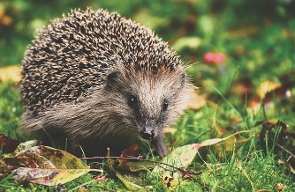

Dusk fades into night, purple to black,
Frogs croak from the pond as they splash around,
Leaping in and out with ease,
But the pond has steep sides, no good for the hedgehogs,
As if he falls in, he’ll be unable to get out,
He cannot swim in the refreshing coolness of the water,
The lonely hedgehog is stuck, in a garden on his own,
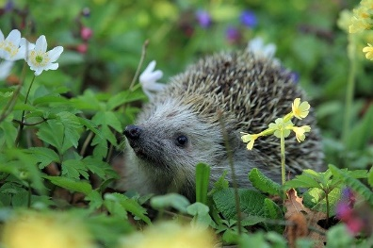

Dusk fades into night, purple to black,
Birds tweet in the trees pecking at the berries,
Flying off happily with satisfies bellies,
But there’s a shortage of food for the hedgehog to eat,
A slug for dinner, a snail for tea,
The hedgehog’s tummy rumbles and aches,
The lonely hedgehog is stuck, in a garden on his own,
Dusk fades into night, purple to black,
Children squeal with glee as a bonfire’s flames crackle,
Oranges and reds illuminate their faces,
But the hedgehog has to flee from the log pile,
Had he been any later then he’d have burned in the flames,
The hedgehog has to find somewhere else to call home,
The lonely hedgehog is stuck, in a garden on his own,
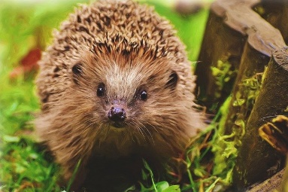

Dusk fades into night, purple to black,
Parents look proudly at their newly strimmed lawn,
Not a grass out of place, not a flower to be seen,
But the hedgehog is injured, a gash on his side,
No long grass to hide in or bugs on the flowers,
He hobbles along in pain he can’t hide,
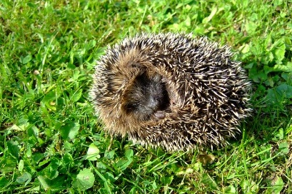
The lonely hedgehog is stuck, in a garden on his own,

Dusk fades to night, purple to black,
A drain lies in wait for its next victim,
Gurgling with glee, muck at its heart,
And the hedgehog falls down innocent and alone,
No one to call to, no one to care,
He’s stuck in a hole, shivering and cold,
The lonely hedgehog is stuck, in a drain on his own,

Night fades to dawn, black to indigo
And the family rush out of their family home,
A saw to make the hole in the fence,
Rocks to make grips on the pond edge,
A plate of cat biscuits, a bowl of water,
Bonfires never again lit unchecked,
Long grass always checked before being cut,
And the lonely hedgehog is lifted out of the drain,
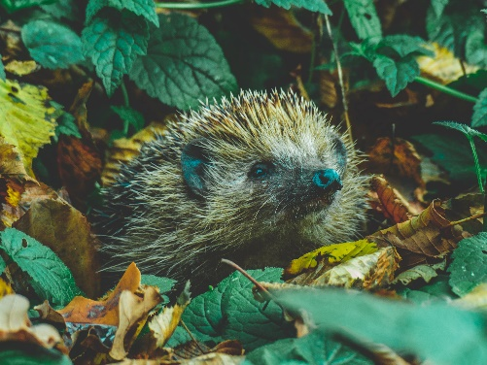
Before a cover is placed over the top,

Day fades to dawn, blue to purple,
The hedgehog now can travel out of the garden,
He can swim, wander and hide without worry,
The hedgehog is safe and sound,
Happy as can be, new hedgehogs can now venture,
Into his garden, ready to be friends,
The happy hedgehog is free, to live a long and healthy life.
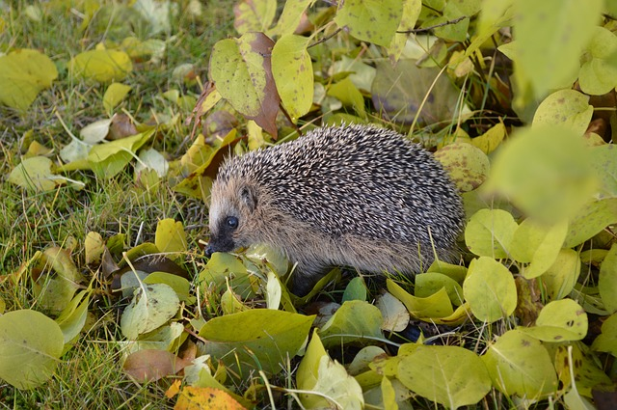
[[ji
Thek

